Route 53 policies

3. Failover Routing

Here if primary will fails it will send traffic to secondary

Here R53 monitor health checks

This is cross-region high availability

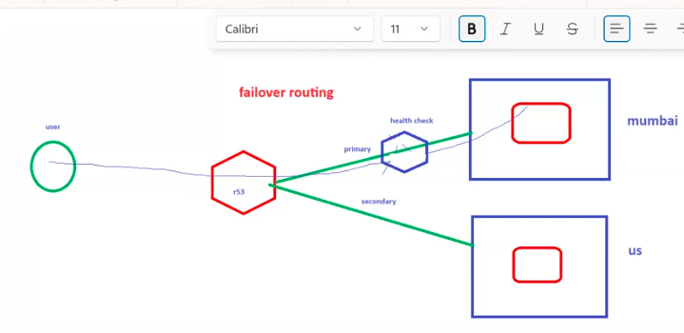

Here we ca do by using IP address of ec2 or DNS of ELB

For this, we need to create health check for only primary ec2 0r ELB DNS.

By using DNS ELB

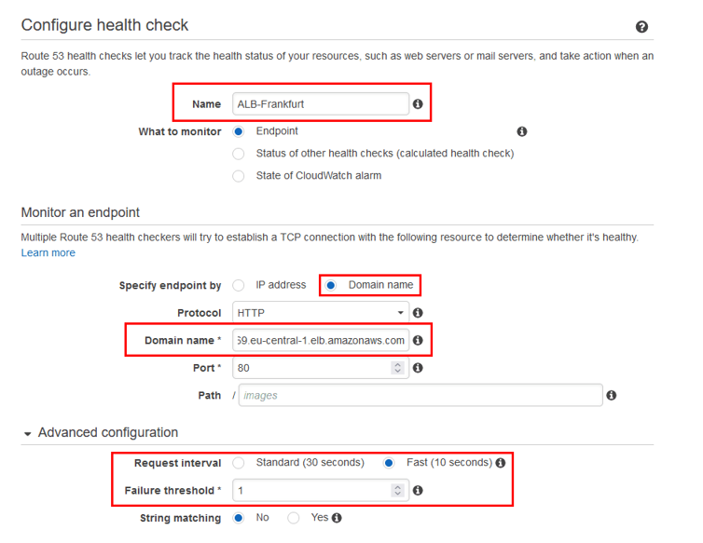

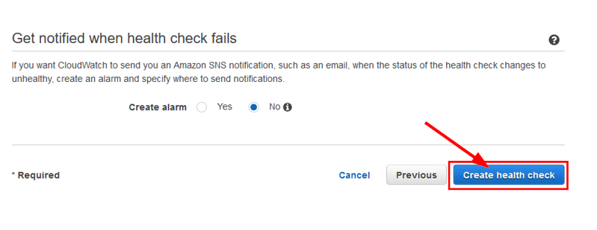

By using IP address

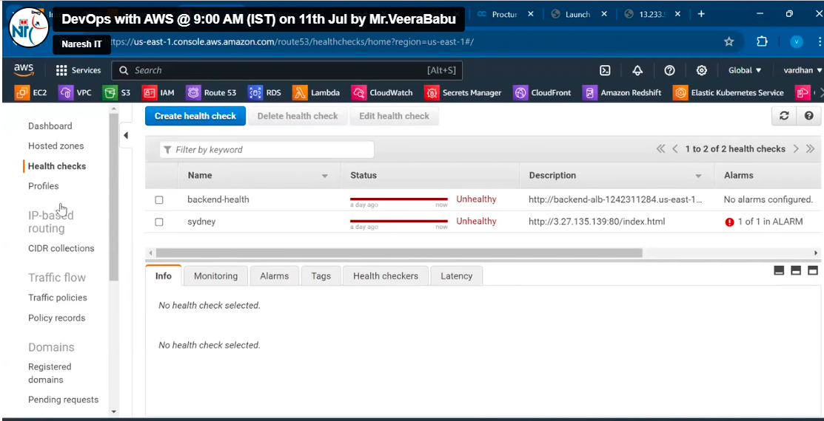

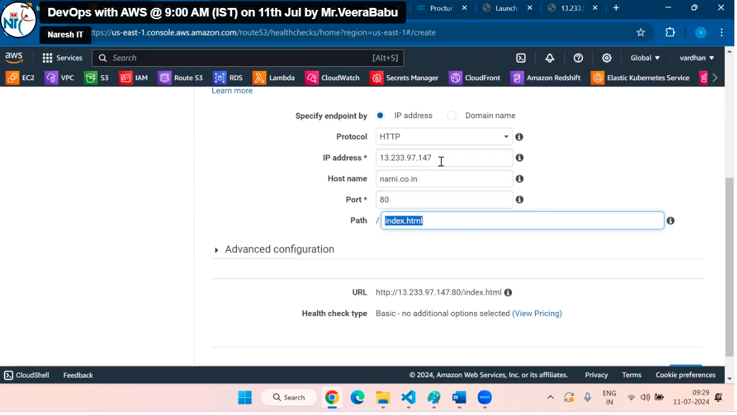

Click on next and create health checks

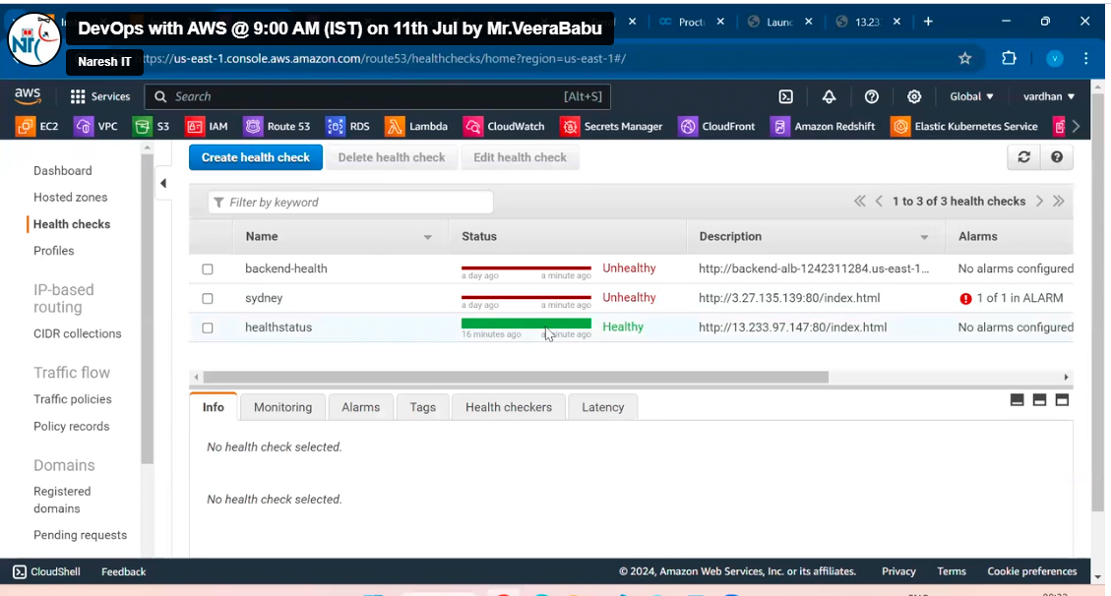

Create primary record

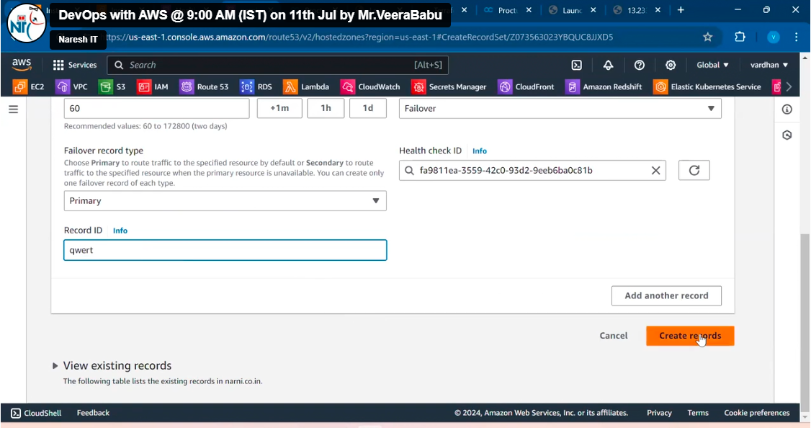

Create secondary record

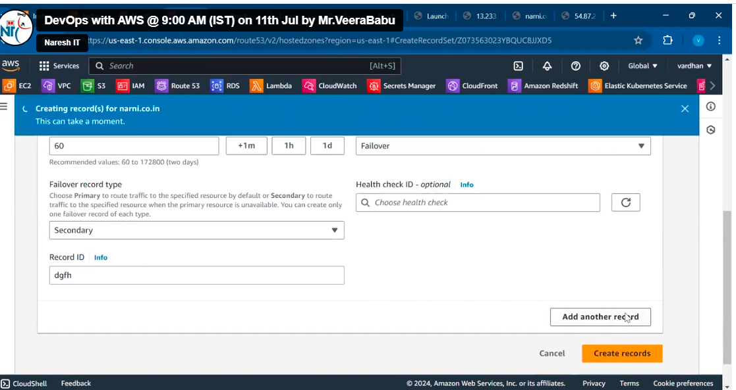

3. Geo location routing policy

In this, we need to select specific location

Here we can create ec2 or ELB may be in any region but we can set specific region or location as option now selected region people can only access the request

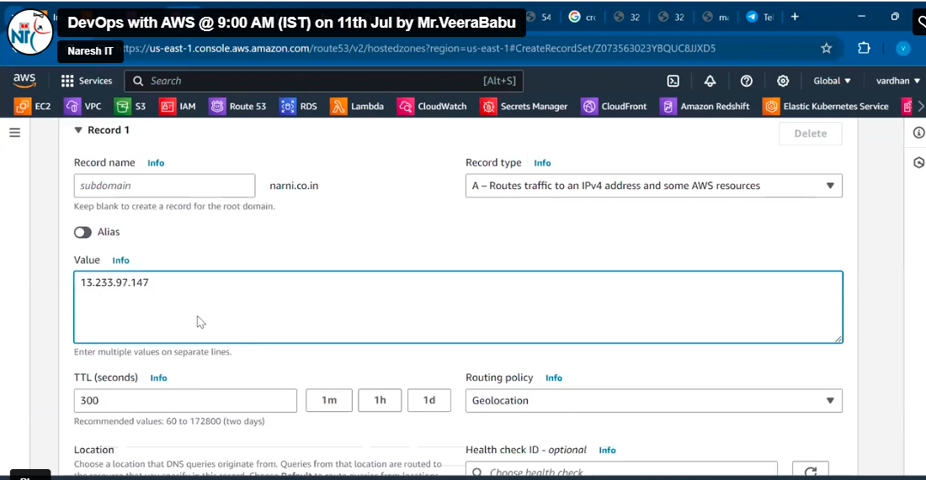

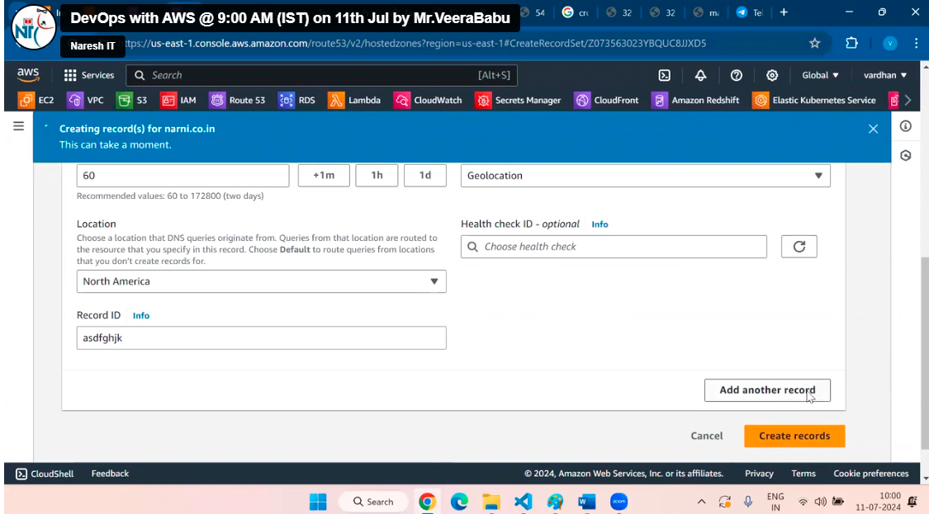

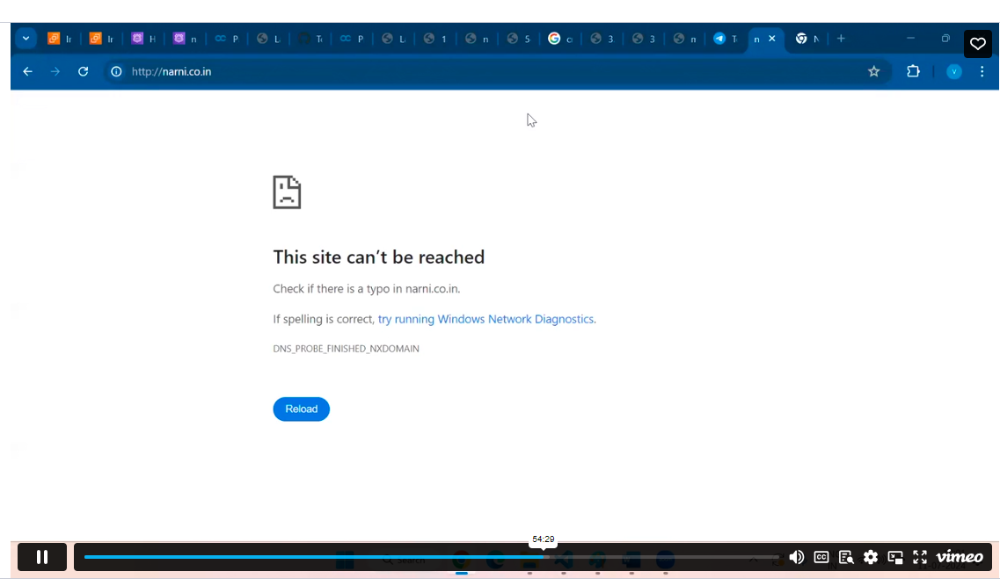

This is because we are accessing from Indian but geo location is North America as give above

IDENTITY ACCESS MANAGEMENT (IAM)

This is very important for any role

It is a AWS security service